Tigard ELL Nature Walk: Learning to Look a Humble Things
Kip Ault, April 20, 2018

Acting requires caring and caring requires
appreciating the astonishing details of the natural world.

Delight itself, however, is a weak term to express the feelings of a naturalist who, for the first time, has wandered by himself in a Brazilian forest. The elegance of the grasses, the novelty of the parasitical plants, the beauty of the flowers, the glossy green of the foliage, but above all the general luxuriance of the vegetation, filled me with admiration. A most paradoxical mixture of sound and silence pervades the shady parts of the wood. The noise of the insects is so loud, that it may be heard even in a vessel anchored several hundred yards from shore; yet within the recesses of the forest a universe of silence seems to reign. To a person fond of natural history, such a day as this brings with it a deeper pleasure than he can ever hope to experience again.  -- Charles Darwin | 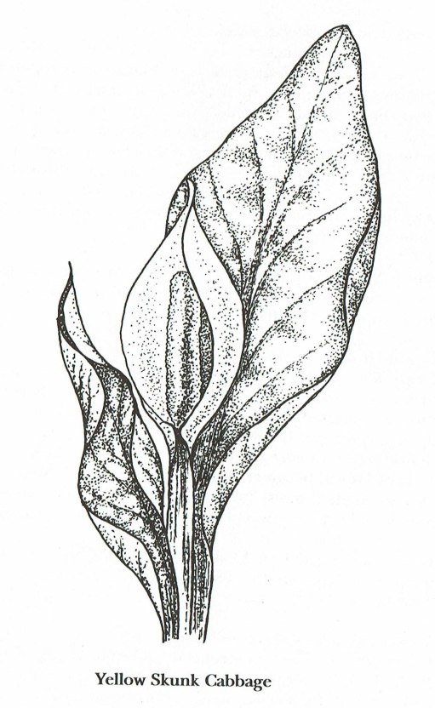  Yellow Skunk Cabbage
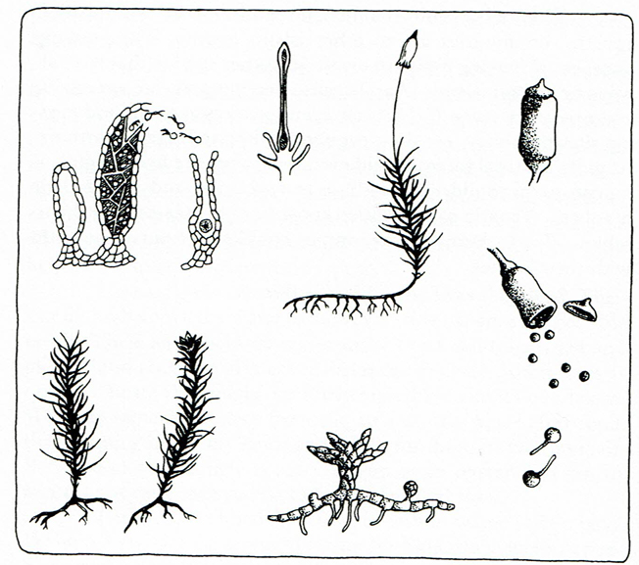  Moss Life Cycle | 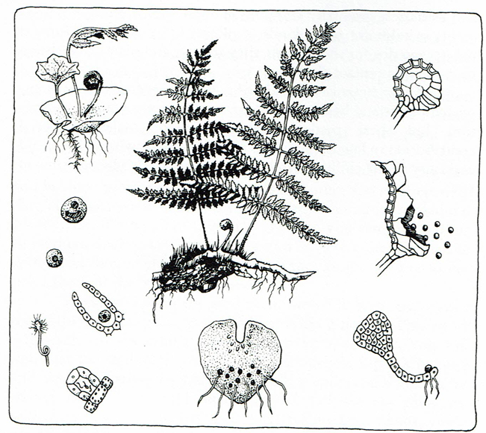  Fern Life Cycle

Ferns are plants that have existed on earth for hundreds of millions of years. Many different kinds grow in Oregon’s shady forests and people like to use them in decorating and landscaping. When you look at a fern you see the large, green “frond.” It has many leaflets called “pinna.” Under the pinna look for brown or black dots. These are “sora” and in each one are many spores. Spores fall to the ground and begin to grow into a new plant called a “prothallus.” This is a tiny plant the size of a small fingernail and in the shape of a heart that almost no one every sees. The little heart-shaped plant soon has male and female parts. In them are sperm cells and egg cells. After a rain, sperm cells swim to the egg cells and fertilize them. A new plant begins to grow. At first it is curled up in a shape known as a “fiddlehead.” Some people like to boil and sauté fiddleheads in olive oil as a tasty, wild vegetable! The name, “fiddlehead,” refers to a fiddle or violin: the end where strings are tightened to tune the fiddle. A fiddlehead unfolds to become a fern frond which grows spores to start the cycle of life over again.

Mosses are soft green plants that cling to logs, wall, trees, roofs, sidewalks, earth, rocks, cliffs—almost anywhere they find a bare patch to grow on. Mosses love water but can survive for a long time even when dry. They typically grow in dense green clumps or mats, often in damp or shady locations. Mosses do not have seeds. Mosses, like ferns, make spores. Moss spores grow above the leaves, not under the leaflets. When moss spores are ripe you can see many “capsules,” each at the end of a thread called a “seta,” rising above the bed of moss. The capsules are filled with spores and are ready to burst and be released into the gentle breezes a few centimeters above the moss. When moss spores fall to the ground and begin to grow as a tiny mat of threads (it’s scientific name is a “protonema”). These thread become stems and leaves as the moss grows. In some some mosses, there are separate male and female stems. In other mosses, male and female parts grow on the same plant. These leafy moss plants produce egg and sperm cells among clusters of specialized leaves at the growing tip of the stem. The female “archegonium” is shaped like a tiny vase and produces egg cells. At the end of a male moss plant sperm develop in an “antheridium.” A drop of rain or dew is all that the moss needs for the sperm to swim to the egg and fertilize it. The splashing of falling raindrops helps sperm make their difficult journey to the archegonium. Tiny springtails and mites also help spread sperm cells. They are attracted to moss odors! Lots of mosses make little cups called “gemmae” that can be knocked off and grow into new, separate moss plants directly. No spores and no egg and sperm stages are necessary! Raindrops knock them loose and small animals running around can brush against moss and spread them. Writer and scientist Robin Wall Kimmerer, a citizen of the Potawatomi Nation, finds lesson for living in the story of mosses. Mosses “give thanks for the rain” (Gathering Moss, 2005).

Skunk cabbages (Lysichiton americanus) belong to a family of plants, the arums (Araceae), with many members that live in tropical places and is related to taro, a food plant of Polynesian people. They roast and dry taro roots and grind them into a flour. If uncooked, taro is poisonous. This plant has a musky odor that attracts flies and beetles in the spring. It’s not as stinky as a skunk, but its name suggests that some people think it has a similar odor. To insects, it must smell like rotting food. (An arum in Sumatra smells so bad its name is “corpse flower.) The leaves are large and it grows in swamps, often in the company of noisy frogs. Its flowers are just plain odd and feature two large structures. One is the club-like “spadix.” On the spadix bloom an enormous number of flowers. A special, bright yellow leaf surround the spadix and grabs attention.

Native American people were quite familiar with skunk cabbage. To the Tillamook it was called q’ilt, the Alsea called it q’ayu’l, to the Siuslaw and Lower Umpqua it was known as ts’yanx, in Hanis Coos has yayax, Milluk Coos and Lower Coquille as kimætl, and in Upper Coquille as kammæ. The plant has waxy leaves that can grow to be a meter (3 feet) long. Some tribes used the leaves to wrap bundles of food in, or put them as a layer in earth ovens to cover the food. The rhizomes were useful as food and medicine.
On the lower Columbia River, the Kathlamet and Clackamas peoples had stories that told that skunk cabbage was an important food and kept people alive before the salmon first came to the rivers. In our Coosan trickster cycle stories, the first trickster learned how to cook skunk cabbage. He tried to eat it raw, but spit it out. Then he put the root in hot ashes to cook. When it smelled sweet, he took it out. It tasted fine now, and so he said that is how human beings will cook it when they come into the world. Then he cut up the root into many pieces and one at a time, picked up a piece and put it down, each time saying “Give this to your…” and naming a different kin name (Mother, father, grandfather, and so on). Many northwestern tribes ate the cooked rhizomes (“rhizomes” are stems that grow underground) of this plant, but some sources state it was not a food that was particularly enjoyed – it was a starvation food. But some people liked it. Lottie Evanoff, a Coos woman born about 1870, said she liked skunk cabbage. She noted that bears liked it too, and ‘whatever bear likes is good eating’. She thought it odd that white people did not eat it.

Keep in mind, skunk cabbage roots have to be thoroughly cooked to be safe to eat. They contain calcium oxalate, which causes a burning sensation in the mouth and can be poisonous. Cooking breaks this compound down. Calcium oxalate is a common in many arums. Taro, a cultivated root food found grown in many parts of Asia and Polynesia, is an arum with these same crystals and so are thoroughly cooked, just as with skunk cabbage.

My Milluk great grandmother “Miluk” is the name of an tribe of Native Americans from the Oregon coast) used to grind up with roots and mix them with honey. She would give a spoonful of this medicine to kids when they had a cold. My older cousins have told me about this medicine – they said it was quite peppery! I am sure it was. Beverly Ward wrote about her husband’s Lower Coquille grandmother Susan Ned. One of her medicines involved skunk cabbage. “She kept a bunch of skunk cabbage and licorice [fern] roots on the wall in the kitchen. She put a big kettle of water on the stove and boiled the roots until the water boiled down, then she used the juice for colds and coughs.”

Contemporary herbalist Michael Moore has also written that medicine derived from skunk cabbage rhizomes can be used to treat minor respiratory troubles. Since I’ve had a bout of bronchitis lately, I’ve almost been tempted to dig up some skunk cabbage and make some medicine and brave its pepperiness. Almost.

Illustrations from A Forest in the City: Your Guide to Tryon Creek State Park by the Friends of Tryon Creek (Saline, MI: McNaughton & Gunn, 1994).
This passage can be found in a blog: Notes on Ethnobotany in Western Oregon. https://ethnobotanywesternoregon.wordpress.com/2011/11/12/skunk-cabbage-%E2%80%93-weird-and-wonderful/ The blog is based on a book by Patricia Whereat-Phillips: Ethnobotany of the Coos, Lower Umpqua and Siuslaw Indians. Sources (Oregon State University Press, 2016). Whereat-Phillips refers to the work of Brown, Deni. 2000. Aroids: Plants of the Arum Family. Second Edition. Timber Press, Portland OR.

